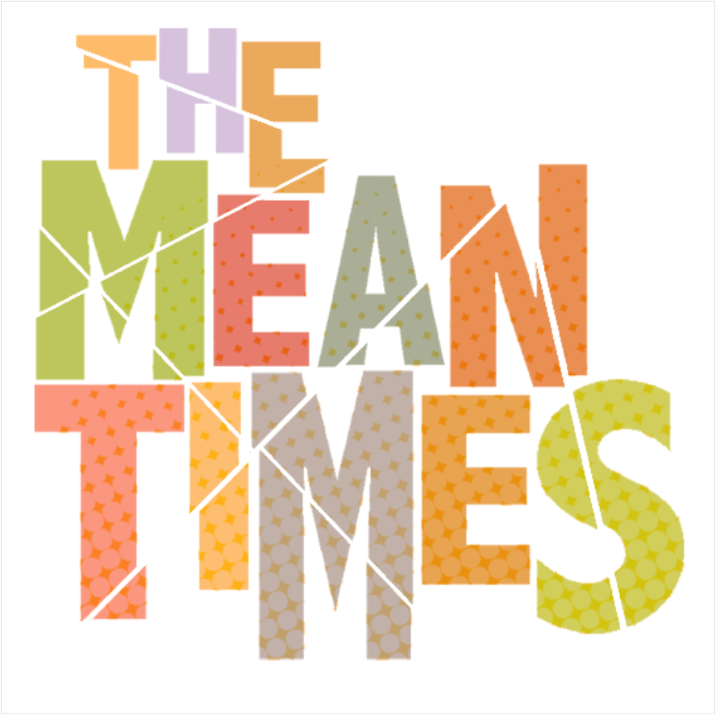
“The Mean Times create infectious, high-energy rock and roll with a let-loose-and-party attitude. Their sound is a pastiche of indie cool with sharp, scuzzy riffs and catchy pop choruses, all delivered with tongue-in-cheek lyrics and a hell of a lot of swagger.” AMNplify

“Pairing swagger with style in equal measure—with a dash of raucous energy—The Mean Times make music that’s good for the soul and that’s always up for a party.”
AAA Backstage

Melbourne quirky punk rock stalwarts The Mean Times have stepped things up a notch of recent times.

Having been a presence in Melbourne's pub rock scene for longer than any ‘emerging band’ probably should, The Mean Times hit beast mode in 2019 with the release of their second EP, 'Raw Prawn'. Containing their comeback pop punk single ‘Sober’, the just plain weird ditty ‘Bananas’ and the immensely popular raucous punk rock track, ‘Be Still My Bleeding Heart’, (described by Triple J presenter Nkechi Anele as being ‘Rock AF; and by American blog YabYum as having “all the energy of a barroom brawl), ‘Raw Prawn’ left their previous years’ output for dead and people wondering where The Mean Times had been their whole lives.

But that’s not all, with the band currently gearing up to drop ‘Stunned Mullet’ in March 2020 – their second EP within a year.

As a fishy series of two, ‘Raw Prawn’ and ‘Stunned Mullet’ were recorded and mixed together at Rolling Stock Studios in Melbourne by Nao Anzai (Cash Savage and the Last Drinks, NO ZU, Kim Salmon) and mastered by Mikey Young of Eddie Current Suppression Ring. While in true guerilla style, the band also added some extra guitar layers and vocals themselves at home.

Following a similar path from happy and bright to sad and dark, the two EPs retained a definite likeness, but are still very different. While ‘Raw Prawn’ is a catchy, punk rock EP that showed the lighter side of The Mean Times, ‘Stunned Mullet’ is an angsty, dystopian rejection of traditional pop and indie norms, while still being catchy, dancey and familiar. Both EPs have retained the garage rock feel of their live show, while adding a new level of depth, space and nuanced dynamics.

Musically the band has seen a shift from the synth power pop leanings of their debut EP, 2014’s 'You’ve Got the Wrong Guys', and the lazy indie meanderings of 2016’s standalone single 'Right Thing, Wrong Time', towards a more mature sound, introducing multi-layered guitars, horns and strings. Gone are the everyday observations and anecdotes of previous releases and in are personal feelings and musings on approaching mid-life and having to adult. It’s teenage angst for people in the mid-late-30s.

Obviously children of the 90s, The Mean Times have taken the best bits of post-grunge power-pop, Brit-pop and Australia’s Triple J heroes of the same era, then thrown in a touch of old school rock and roll, to create their own brand of quirky, everyday-man’s Oz rock. Their musical inspiration comes from the likes of You Am I, The Fauves, Pixies, Queens of the Stone Age, Weezer, Regurgitator, Split Enz, Rolling Stones, Blur, Custard, Bad//Dreems and Pavement.

Having played almost every venue in Melbourne, and many more beyond, The Mean Times (Eoin Clements on guitar and vocals, Rob Meerbach on bass and vocals, Ryan Williams on drums and vocals and Tom Morgan on vocals and guitar) deliver a raucous, high-energy, spirited live show that makes you smile. They're raw yet polished; weird, yet digestible; punk yet pop. The music and the men are real and concise. They write good songs for music lovers, not slow jams for pool party posers. They're definitely not on trend, but they're The Mean Times and they’re only cool unto themselves.

“Our new favorite band is here with new music and it comes as no surprise that it’s straight heat. We love the creative force behind The Mean Times’ sound and their vision has always been on point. We have a feeling this is just a small taste of what’s to come.”
Keep Walking Music

